**Spike:**  *17*

**Title:** Create Simple Blueprint in C++

**Author:** Steven Efthimiadis, 1627406

**Goals / deliverables:**

The goal is to create a c++ that holds x, y and z as float variables and you must be able to get and then set them to different values.

To create this spike, you require:

* Knowledge of c++ in OOP
* Blueprints

**Technologies, Tools, and Resources used:**

List of information needed by someone trying to reproduce this work

* Blueprints collaborating with c++
  + <https://forums.unrealengine.com/showthread.php?110892-40-step-by-step-C-tutorials-for-UE4>

**Tasks undertaken:**

* Create a Blueprint for 3D Vector
* Create a c++ class for 3D Vector.
* Add it to the blueprint.
* Create input for getting and setting for X, Y and Z variables.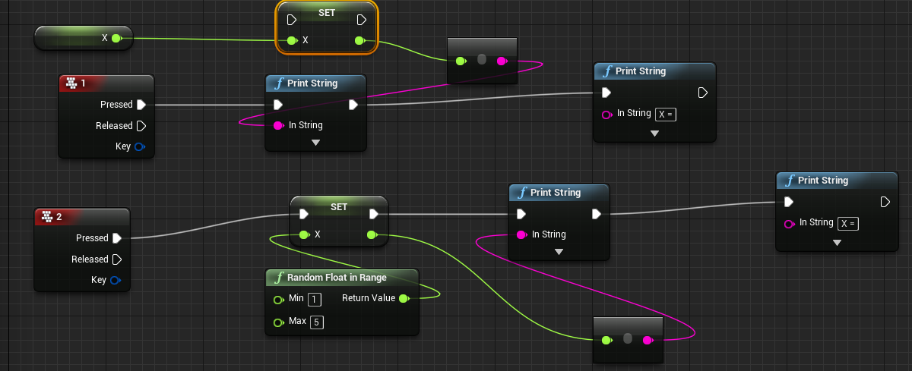

**What we found out:**

* You need to compile the game or the blueprints won’t recognize that you have created a c++ class.
* When creating the actor, you need to create it as an actor and then select it as an instance of the c++ file you created so you can access the variables you made.
* You need to create a new instance of the c++ class so the functions in the blueprints can link to it.

**Open issues/ risks:**

* The unreal tutorial doesn’t explain how to add the variables from the c++ file to the program properly so:
  + When creating the actor, you need to create it as an actor and then select it as an instance of the c++ file you created so you can access the variables you made.
  + You need to create a new instance of the c++ class so the functions in the blueprints can link to it.